Project Plan - Methodology

Selected Methodology: Agile Development

Introduction :-
Agile Development is a software development methodology that divides a project into small parts that can be developed, tested, and improved incrementally. It emphasizes flexibility, teamwork, communication, and continuous feedback.

Why Agile Was Selected ?
Agile Development was selected for the Meeting Room Booking
System for the following reasons:
1. Flexibility: The team can modify system requirements when necessary.
2. Team Collaboration: The five team members can coordinate their work and share responsibilities.
3. Incremental Development: The system can be developed feature by feature.
4. Continuous Testing: Each feature can be tested before moving to the next stage.
5. Feedback and Improvement: Feedback can help the team improve the system during development.

Applying Agile to the Meeting Room Booking System :-
The project will be divided into the following iterations:
Iteration 1: Requirements Analysis
- Identify the needs of employees and administrators.
- Determine the problems with the current meeting room booking process.
- Define the system requirements.
Iteration 2: System Design
- Design the user interface.
- Design the database for rooms, users, and bookings.
- Define the booking workflow.
Iteration 3: Core System Development
- Display available meeting rooms.
- Allow users to book rooms for specific dates and times.
- Prevent overlapping bookings.
Iteration 4: Additional Features
- Allow users to modify or cancel bookings.
- Enable administrators to manage rooms and reservations.
- Display booking details and confirmation.
Iteration 5: Testing and Evaluation
- Test room availability and reservation functionality.
- Check that booking conflicts are prevented.
- Fix errors and improve the system based on feedback.

Advantages of Agile for Our Project :-
Agile Development allows the team to develop the Meeting Room Booking System incrementally, identify problems early, coordinate responsibilities, and improve features throughout development.

Conclusion :-
Agile Development allows the team to develop the Meeting Room Booking System incrementally, identify problems early, coordinate responsibilities, and improve features throughout development.

Time Estimation

 | Standard percentages | Estimated time based on planning time
Planning | 19.05 % | 8 days
Analysis | 21.43 % | 9 days
Design | 21.43 % | 9 days
Implementation  & Testing | 57.14 % | 24 days
Total | 100 % | 50 days

Case Study: Business System Implementation

Background:-
- An organization needs an efficient way to manage its meeting rooms and reservations.
- Employees need to book meeting rooms for meetings, discussions, and training sessions.
- The organization plans to implement a Meeting Room Booking System to improve the reservation process.

Problems Identified:-
- Difficulty checking meeting room availability.
- Double booking of the same meeting room.
- Manual booking procedures that waste time.
- Difficulty managing booking modifications and cancellations.
- Lack of centralized booking information.

Project Objectives:-
- Organize all meeting room reservations in one system.
- Allow users to check room availability.
- Prevent overlapping reservations.
- Simplify booking, modification, and cancellation.
- Help administrators manage rooms and reservations.

System Development Plan:-
The project team plans to follow the System Development Life Cycle (SDLC) to analyze, design, develop, test, and implement the Meeting Room Booking System.

Key SDLC Phases:-
1. Planning – Identify project goals, feasibility, resources, and the project schedule.
2. Analysis – Gather user requirements through interviews and questionnaires.
3. Design – Prepare the Data Flow Diagram (DFD), Entity Relationship Diagram (ERD), database design, and user interface.
4. Implementation – Develop the booking system and its main functions.
5. Testing – Test room availability, reservations, and booking conflict prevention.
6. Deployment – Make the system available to users and provide basic instructions.
7. Maintenance – Fix problems and update the system when necessary.

Questions:-
1. Which SDLC methodology is most suitable for developing the Meeting Room Booking System, and why?
2. How can the proposed system solve the identified problems?

Methodology Options:-
1. Waterfall Method
2. Parallel Method
3. Rapid Application Development (RAD)
4. Iterative Method
5. Agile Development

Name | System Request
ID | 1
Start Date | 18 / 10 / 2026
End Date | 19 / 10 /2026
Person Assigned | Project Manger
Priority | High
Resources Needed | Client Brief
Estimated Time | 2 Days
Actual Time | Not Stated
Predecessors | None
Slack | 0 Days
Project Identifications
Name | Feasibility Study
ID | 2
Start Date | 20 / 10 / 2026
End Date | 23 / 10 /2026
Person Assigned | Business Analysis
Priority | High
Resources Needed | Cost Sheet
Estimated Time | 4 Days
Actual Time | Not Stated
Predecessors | 1
Slack | 0 Days

Name | Project Plan (Gantt-Chart)
ID | 3
Start Date | 24 / 10 / 2026
End Date | 26 / 10 /2026
Person Assigned | Project Manger
Priority | Medium
Resources Needed | MS Project
Estimated Time | 3 Days
Actual Time | Not Stated
Predecessors | 2
Slack | 0 Days

Name | Risk Assesment
ID | 4
Start Date | 24 / 10 / 2026
End Date | 25 / 10 /2026
Person Assigned | Project Manger
Priority | Medium
Resources Needed | Risk Register
Estimated Time | 2 Days
Actual Time | Not Stated
Predecessors | 2
Slack | 1 Days

Name | Stakeholder Interviews
ID | 5
Start Date | 27 / 10 / 2026
End Date | 31 / 10 /2026
Person Assigned | Business Analyst
Priority | High
Resources Needed | Interview Guide
Estimated Time | 5 Days
Actual Time | Not Stated
Predecessors | 3 , 4
Slack | 0 Days

Name | User Questionnaire
ID | 6
Start Date | 27 / 10 / 2026
End Date | 30 / 10 /2026
Person Assigned | Business Analyst
Priority | Medium
Resources Needed | Survey Tool
Estimated Time | 4 Days
Actual Time | Not Stated
Predecessors | 3
Slack | 1 Days

Name | Use Casr & Requirements
ID | 7
Start Date | 01 / 11 / 2026
End Date | 04 / 11 /2026
Person Assigned | System Analyst
Priority | High
Resources Needed | UML Modelling Tool
Estimated Time | 4 Days
Actual Time | Not Stated
Predecessors | 5 , 6
Slack | 0 Days

Name | Data Flow Diagram
ID | 8
Start Date | 05 / 11 / 2026
End Date | 08 / 11 /2026
Person Assigned | System Analyst
Priority | High
Resources Needed | Diagraming Tool
Estimated Time | 2 Days
Actual Time | Not Stated
Predecessors | 7
Slack | 5 Days

Name | ER Diagram
ID | 9
Start Date | 05 / 11 / 2026
End Date | 08 / 11 /2026
Person Assigned | Database Designer
Priority | High
Resources Needed | ER Modelling Tool
Estimated Time | 4 Days
Actual Time | Not Stated
Predecessors | 7
Slack | 0 Days

Name | Process Specification
ID | 10
Start Date | 09 / 11 / 2026
End Date | 11 / 11 /2026
Person Assigned | System Analyst
Priority | Low
Resources Needed | Documentation Tool
Estimated Time | 3 Days
Actual Time | Not Stated
Predecessors | 8
Slack | 26 Days

Name | Database Design
ID | 11
Start Date | 09 / 11 / 2026
End Date | 13 / 11 /2026
Person Assigned | Database Designer
Priority | High
Resources Needed | MySQL Server
Estimated Time | 5 Days
Actual Time | Not Stated
Predecessors | 9
Slack | 0 Days

Name | UI Wireframes
ID | 12
Start Date | 05 / 11 / 2026
End Date | 09 / 11 /2026
Person Assigned | UI / UX Designer
Priority | Medium
Resources Needed | Figma
Estimated Time | 5 Days
Actual Time | Not Stated
Predecessors | 7
Slack | 4 Days

Name | Booking Module
ID | 13
Start Date | 14 / 11 / 2026
End Date | 23 / 11 /2026
Person Assigned | Backend Developer
Priority | High
Resources Needed | IDE & DEV Server
Estimated Time | 10 Days
Actual Time | Not Stated
Predecessors | 8 , 11 , 12
Slack | 0 Days

Name | Auth & Admin Module
ID | 14
Start Date | 14 / 11 / 2026
End Date | 19 / 11 /2026
Person Assigned | Backend Developer
Priority | Medium
Resources Needed | IDE &  Auth Library
Estimated Time | 6 Days
Actual Time | Not Stated
Predecessors | 11
Slack | 8 Days

Name | Email Remiders
ID | 15
Start Date | 24 / 11 / 2026
End Date | 27 / 11 /2026
Person Assigned | Backend Developer
Priority | Low
Resources Needed | STMP Mail Service
Estimated Time | 4 Days
Actual Time | Not Stated
Predecessors | 13
Slack | 0 Days

Name | System Testing
ID | 16
Start Date | 28 / 11 / 2026
End Date | 04 / 12 /2026
Person Assigned | QA Engineer
Priority | High
Resources Needed | Test Cases
Estimated Time | 7 Days
Actual Time | Not Stated
Predecessors | 13 , 14 , 15
Slack | 0 Days

Name | Deployment  & Training
ID | 17
Start Date | 05 / 12 / 2026
End Date | 07 / 12 /2026
Person Assigned | DevOps Engineer
Priority | Medium
Resources Needed | Hosting &  User Guide
Estimated Time | 3 Days
Actual Time | Not Stated
Predecessors | 16
Slack | 0 Days

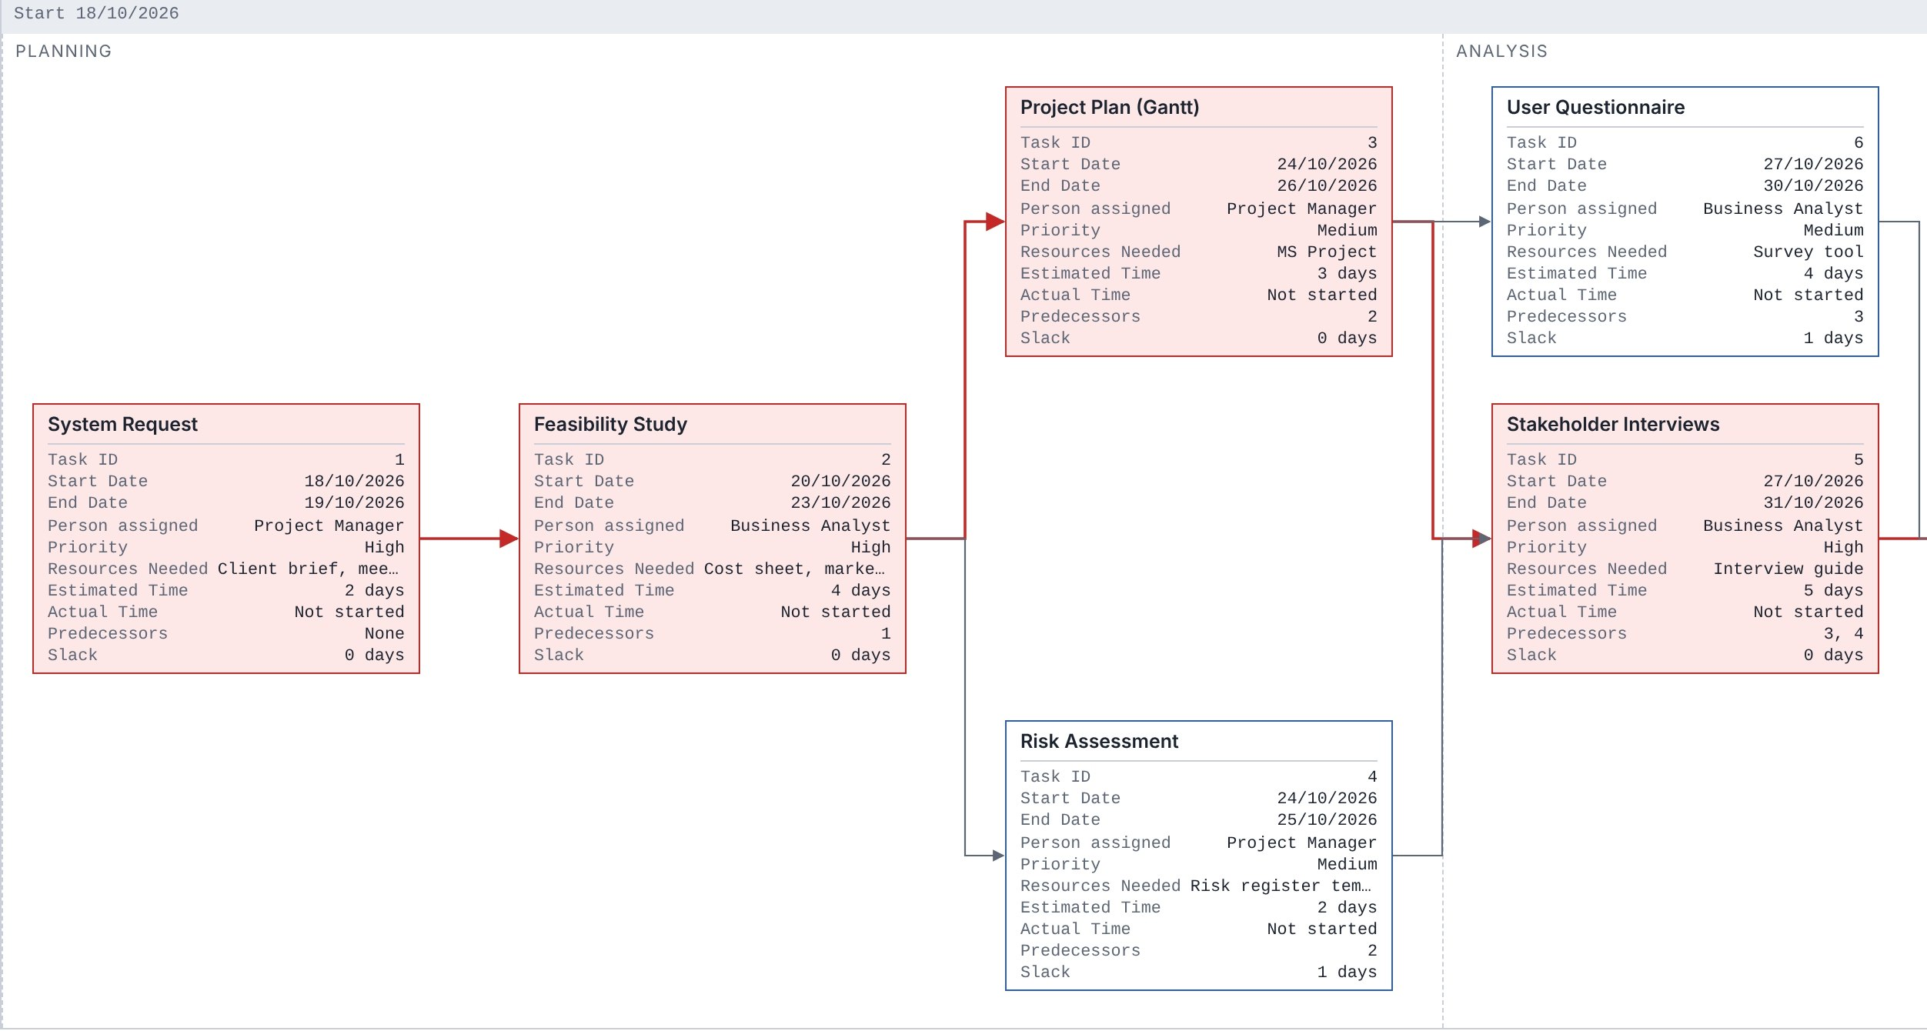
Pert Chart

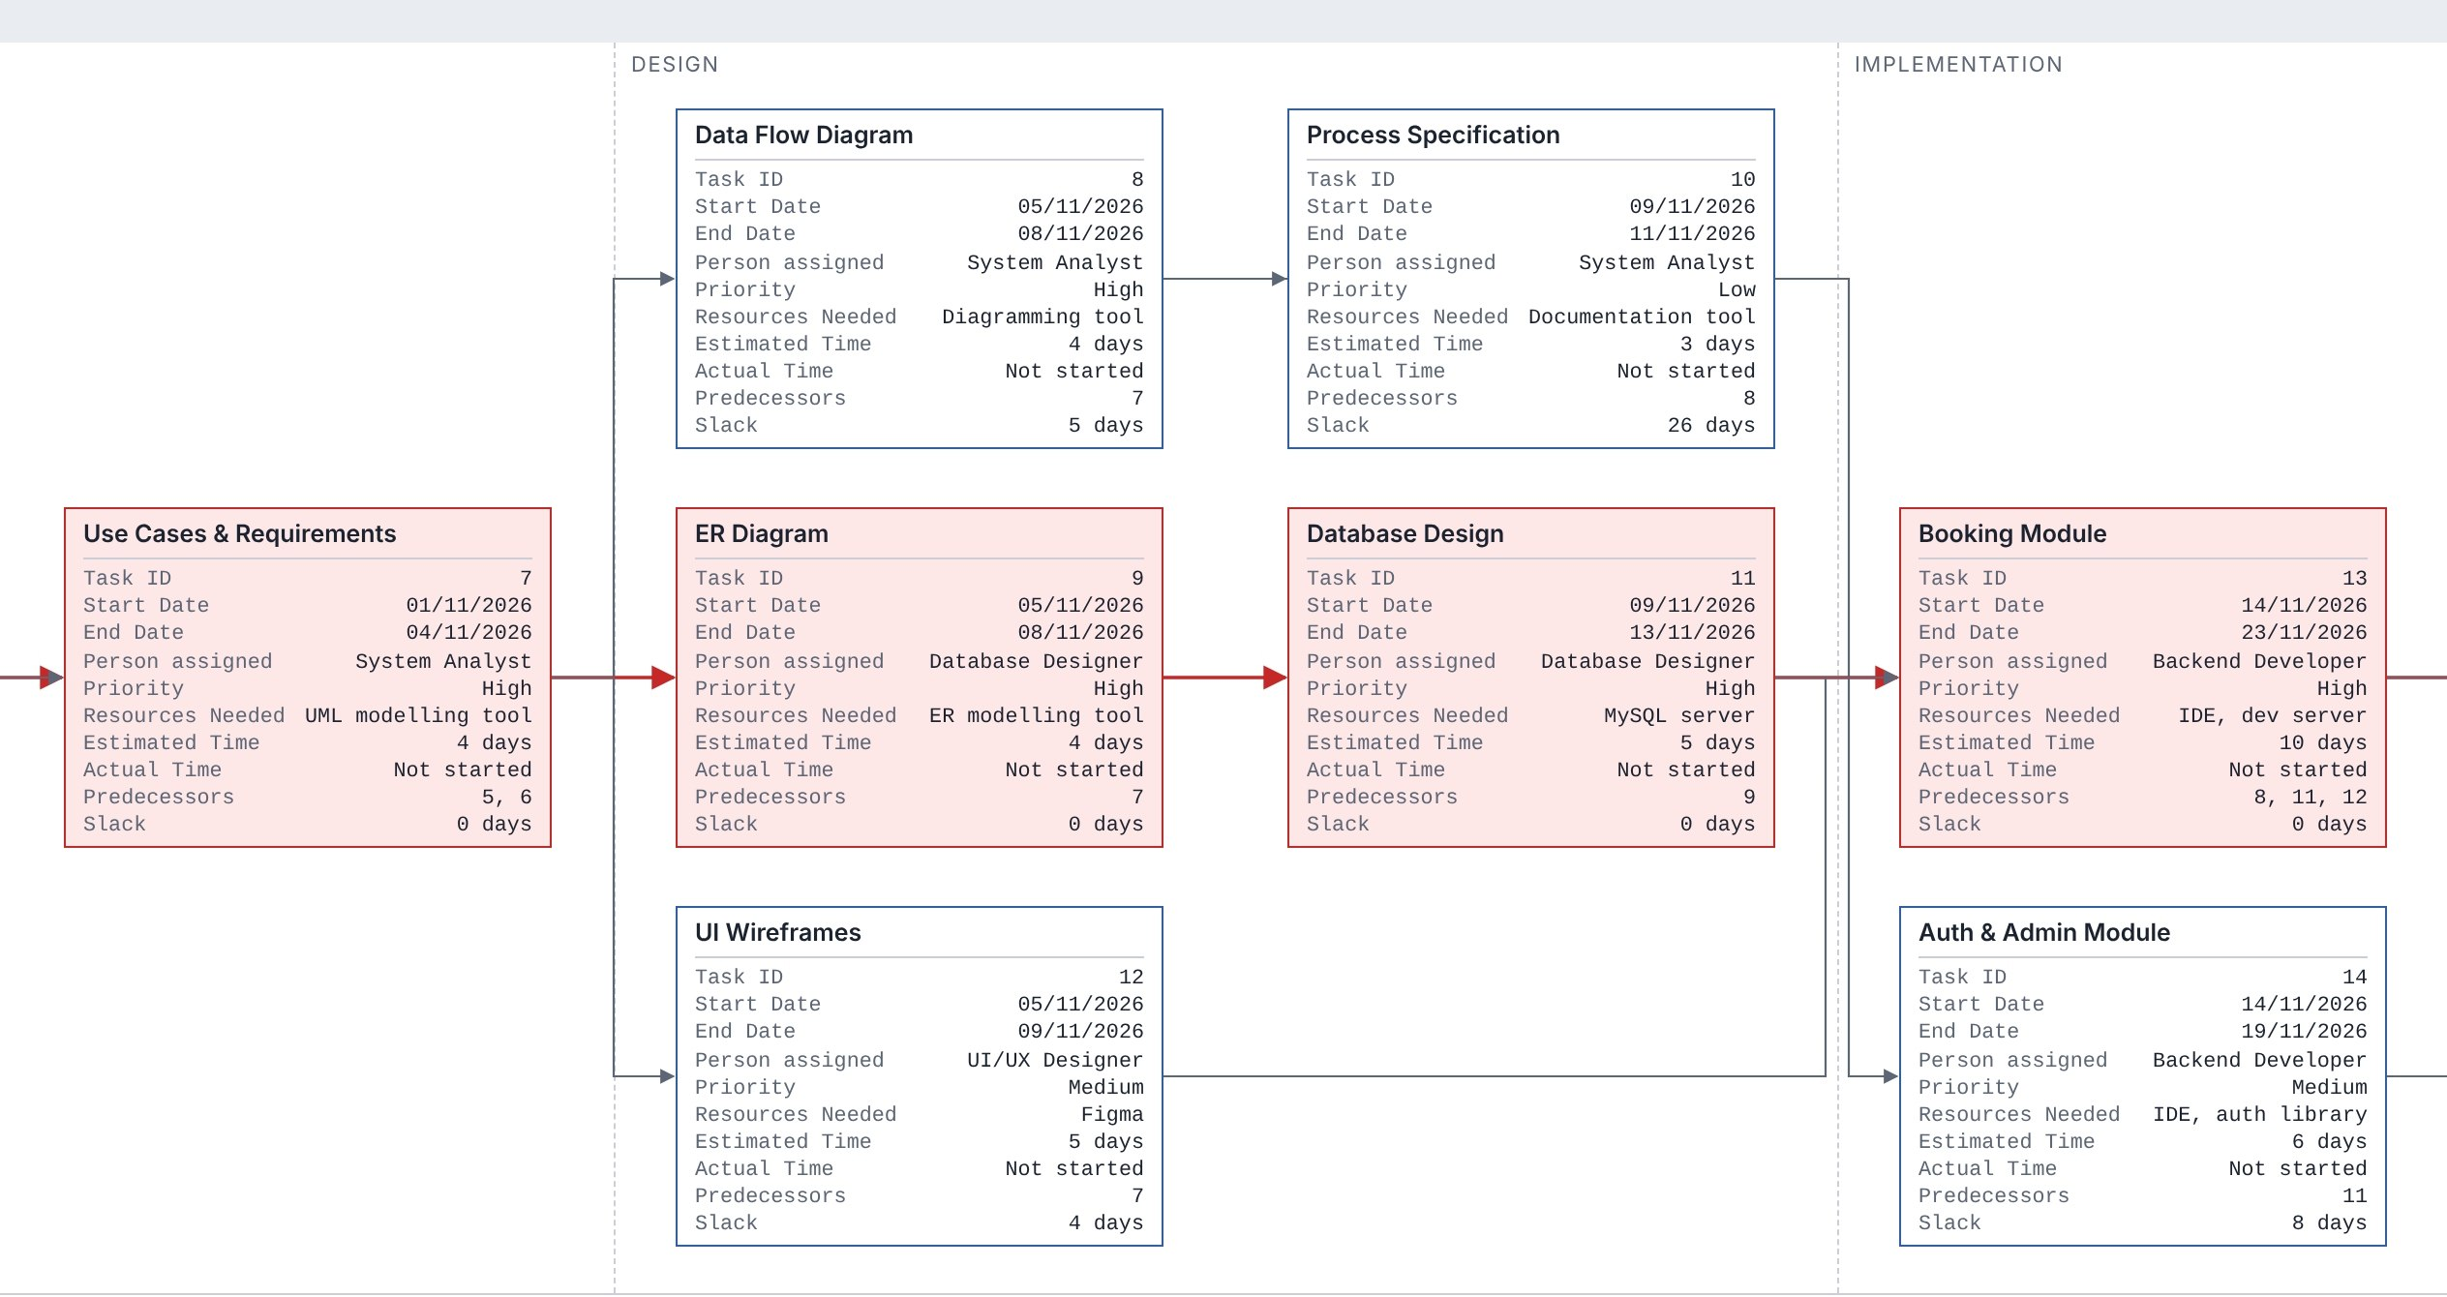

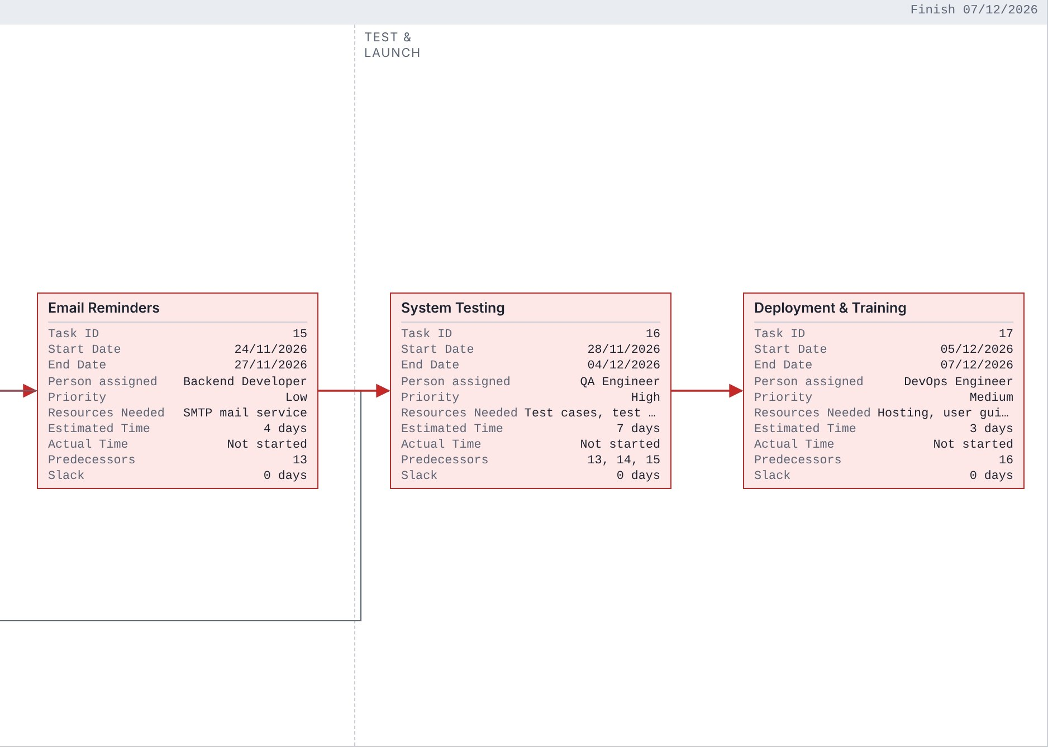

Gantt Chart
